BIG DATA ANALYTICS LAB

Exp-3. Writing User Defined Functions/Eval functions for filtering unwanted data in Pig

Date: 10-02-2025

hadoop@ubuntu22:~/Desktop/RMMBDALAB/Exp-3.Pig/Pig_UDF$ jython –version

Jython 2.7.2-DEV

hadoop@ubuntu22:~/Desktop/RMMBDALAB/Exp-3.Pig/Pig_UDF$ pig -x local

grunt>

grunt> set script.pig.udf.import.list myudf;

grunt> REGISTER 'myudf.py' USING jython AS myudf;

grunt> students = LOAD 'students.txt' USING PigStorage(',') AS (name:chararray, marks:int);

grunt> passed_students = FILTER students BY myudf.pass_students(marks) == 'true';
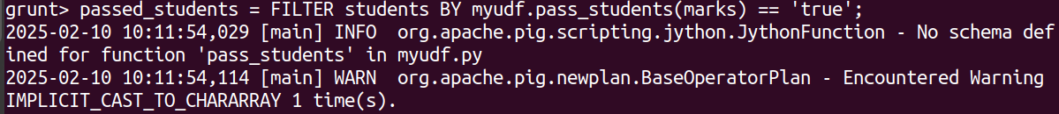
grunt> DUMP passed_students;

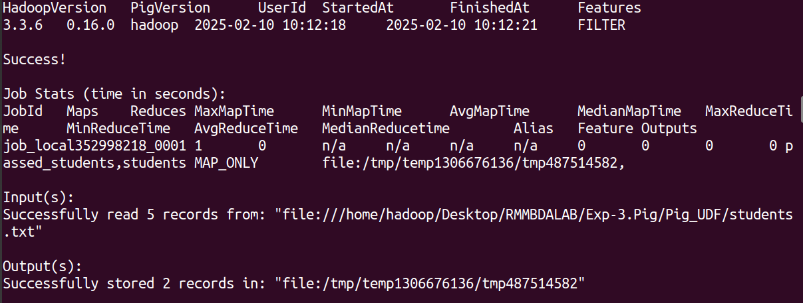
- Total input paths to process : 1
(Bob,60)
(Charlie,80)

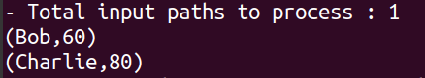

grunt> squared_values = FOREACH students GENERATE name, myudf.square(marks);

grunt> DUMP squared_values;

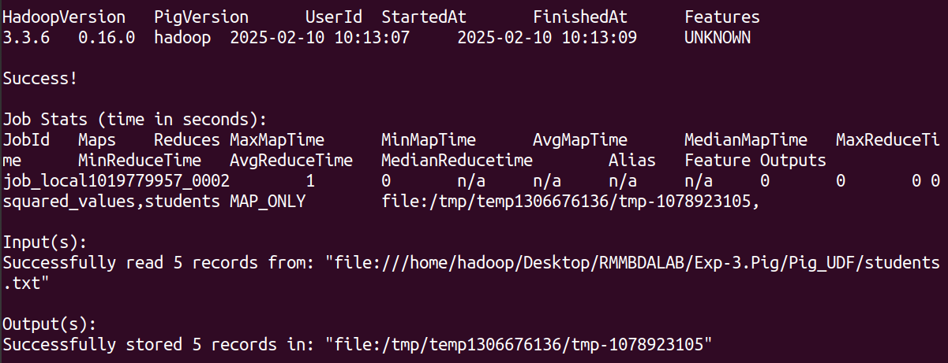

- Total input paths to process : 1
(Alice,2025)
(Bob,3600)
(Charlie,6400)
(David,900)

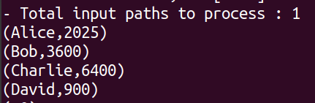

Source Files:

students.txt:

Alice,45
Bob,60
Charlie,80
David,30

Mapper Python Code: myudf.py

# myudf.py - Jython UDFs for Pig

# Filter UDF
def pass_students(marks):
if marks is None:
return 'false'
return 'true' if int(marks) > 50 else 'false'

# Eval UDF
def square(num):
if num is None:
return 0
return int(num) * int(num)

